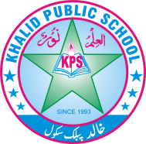
Q. No: 1 Encircle the correct option. /10
Subject: General Knowledge Total Marks: 50___ _____
Month Test: __ __august ___ Obt. Marks: ________________
Theme/Unit: ________ _______ Grand total:_______50 ______
Objective:____________________ ID: ____________________
Name: ______________________ class: ___3rd Section: _________________

1- It is no longer found on Earth-------
(a) Black buck (b) Crocodile (c) Dinosaur
2- Trees are a great source of-------
(a) Heat (b) Oxygen (c) Water
3- People who provide goods or services are called-------
(a) Human resource (b) Capital resource (c) Natural resource
4- When things are scarce, we have to make-------
(a) Choices (b) More things (c) Less things
5- Crude oil is converted into many petroleum products such as petrol and-------
(a) Diesel (b) Glass (c) Wax
6- Which of the following is not a source of energy?
(a) Soil (b) Wind (c) Water
7- They fill the entire space of a container-------
(a) Solids (b) Liquids (c) Gases
8- Our shadow is the shortest at the---------
(a) Morning (b) Noon (c) Evening
9- The young one of a frog is called a-------
(a) Chicken (b) Pupa (c) Tadpole
10- ---------- are used as a fuel in the vehicles.
(a) Coal (b) Oil (c) Water

Q. No: 2 Fill in the blanks. /5

- A ------------------------------is a person who gets things for money.
- Machinery and tools are ---------------------------- resources.
- Tigers and lions are found in ------------------------------.
- A place where animals and plants live and grow is called -----------------------------.
- A teacher provides -------------------------------- services.

Q. No: 3 Write T for a true and F for a false statements. /5

- Dams produce wind energy. ----------
- We need energy to do work. ----------
- Smog is a form of a solid. ----------
- The sun only castes shadows of living things. ----------
- Sunflower plant grow from grafting. ----------

Q. No: 4 Match the resources with their types. /6
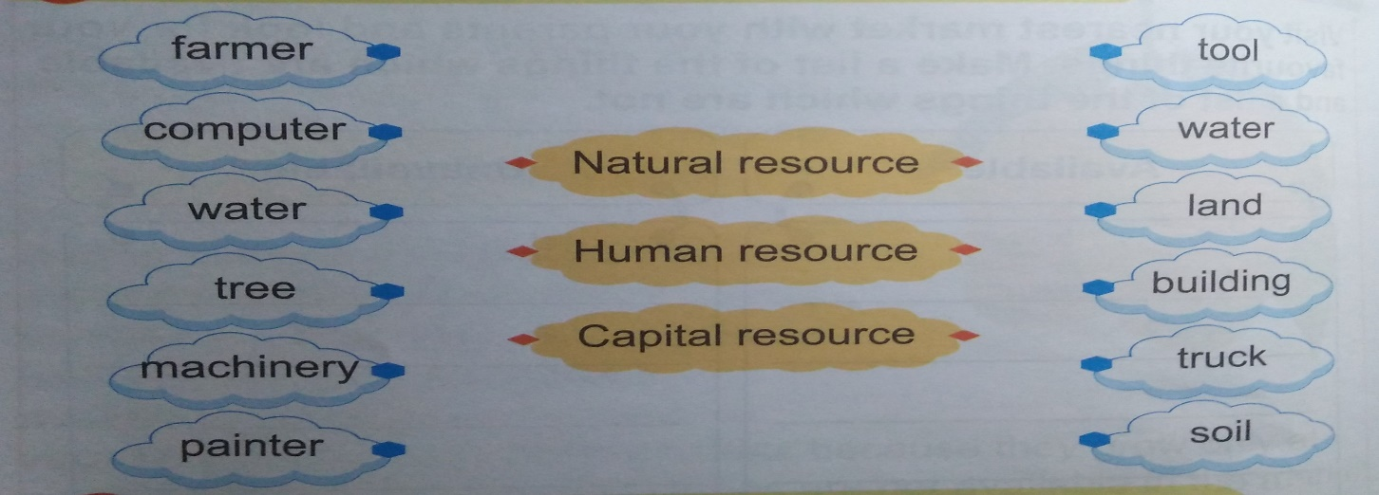

Q. No: 5 Answer the following questions. /10
- Why do animals become extinct?
---------------------------------------------------------------------------------------------------------------
- What is scarcity? Explain the term with an example.
---------------------------------------------------------------------------------------------------------------
---------------------------------------------------------------------------------------------------------------
- What is the use of gas and coal?
------------------------------------------------------------------------------------------------------------------------------------------------------------------------------------------------------------------------------
- What is matter? Give examples.

---------------------------------------------------------------------------------------------------------------
- List some human activities that affect the habitats of living things.

Q. No: 6 Recall and reply. /3
What will happen if all the water on Earth dries up?

---------------------------------------------------------------------------------------------------------------
Q. No: 7 Work it out. /4
Visit your nearest market with your parents and look for your favourite things. Make a list of the things which are available and a list of the things which are not.
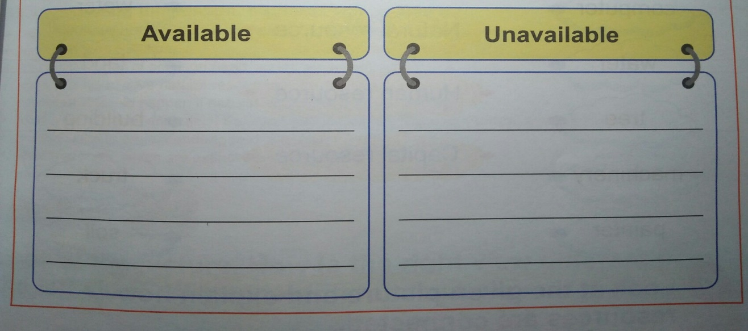

Q. No: 8 Write whether the following animals are endangered or extinct. /4
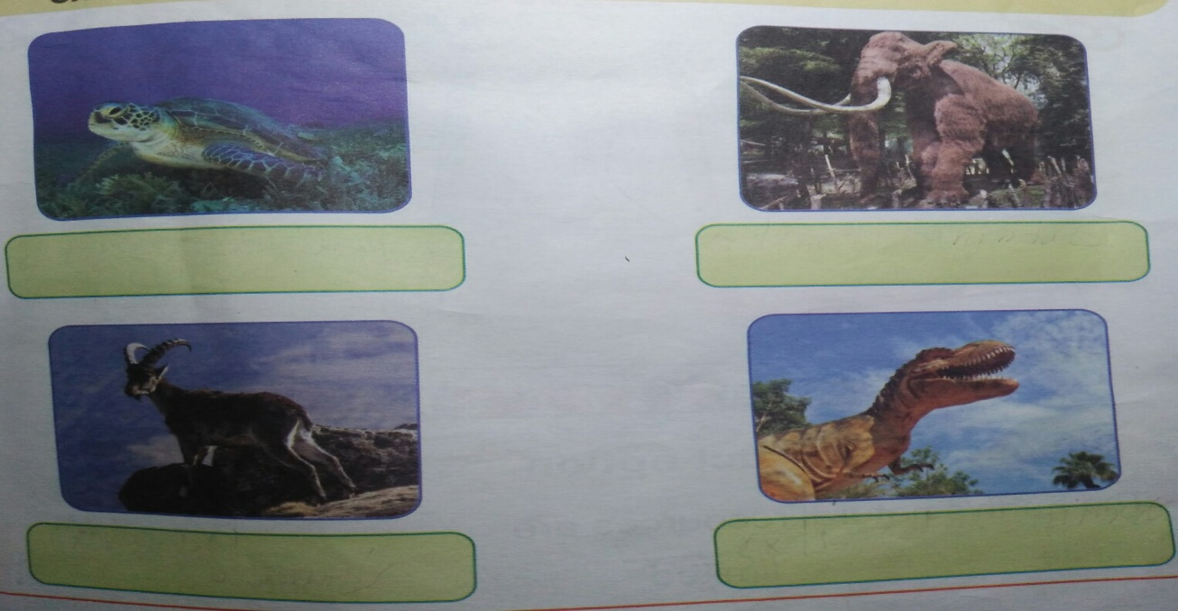

sQ. No: 9 Lets try it. /3
Complete the following mind map with natural things (air, water, forest etc) found on Earth.
